Experiential Learning Application 4-Chapter 6
Name
Institutional Affiliation

Experiential Learning Application 4-Chapter 6
Introduction
Immunization plays a critical role in the public healthcare system. Lack of proper immunization is associated with increased levels of mortality and morbidity on the US and worldwide. According to Ventola (2016), childhood immunization has been proven as one of the best public health strategies for controlling and preventing the spread of disease. In order to reduce the levels of childhood mortality and morbidity, the CDC issues a yearly guidelines and recommendations for both childhood and adolescent immunization. The issue of vaccination has created a lot of social and political discussion in the US and Europe. There parents who are opposed to child immunization and the failure to vaccinate or delay in doing so can be affected by religious, medical, philosophical as well as socioeconomic reasons.
In this analysis, The SEMMA process was used for analysis of the dataset. The process started with systematic sampling, exploration, modification, modelling and assessment of the dataset. The entire process was done inside the SAS Enterprise Miner environment.
Sample
The sampling process was done as follows;
Variable identification;
Data Set Variable | Role | Level
RecordID | Indicated the record ID of the patient | Interval
Year | The year of immunization | Interval
State | The state of the immunized patient | Nominal
Gender | The gender of the immunized patient | Nominal
Age Group | The age group of the immunized patient | Nominal
Race/Ethnicity | The race of the immunized patient | Nominal
Education_Attained | The educational attainment of the immunized patient | Nominal
FluShotVaccine_Immunization | Whether or not the patient has been immunized-This acted as the secondary or target variable | Interval

Adding the file import node;
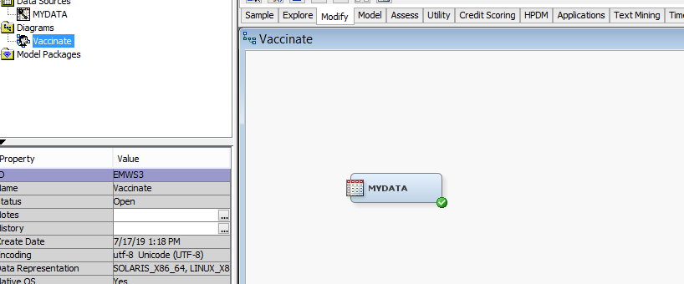
A result overview of the target variables and level of variable is shown below;
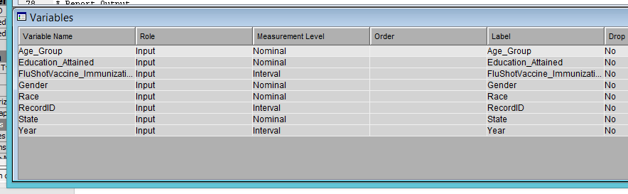
Generating data partition
Data partitioning is an important process sin data mining since when working with large sample sizes, it helps with model fitting, training, validation and testing. The data partitioning process was accomplished through a simple random method. Of the data set 40% was used for training, 30% for validation and the remaining 30% left for testing. The process is shown in the screenshot below;
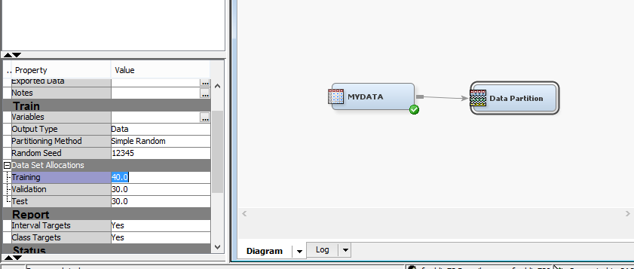
The result of the data partition was as follows (an overview);
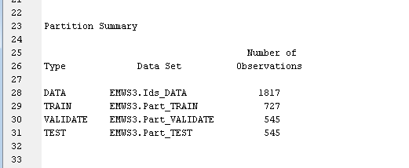
Explore
Data exploration was done using a STAT EXPLORE node, GRAPH EXPLORE node, and a MULTIPLOT node. The summary of the explore stage was as follows;
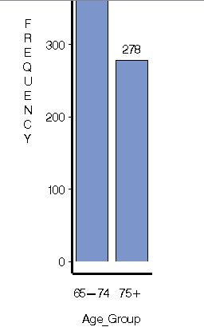
The summary/ descriptive statistics were as follows;
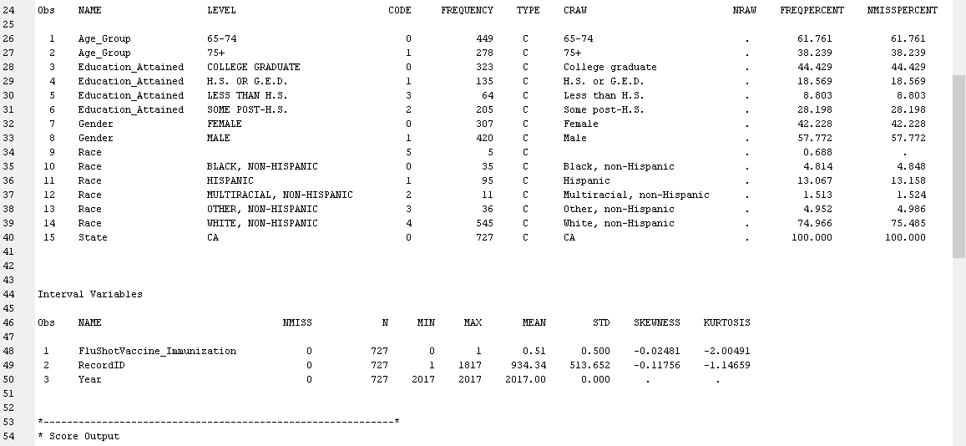
Missing data
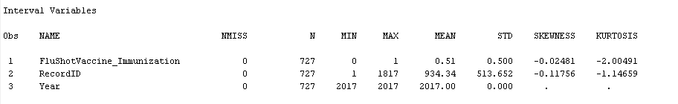
Outliers
Modify
The modify node is used in the data analysis process to include further modification to the data stream. The modification that was selected for this stage was data imputation. Data imputation or impute node was used at this stage to replace all kissing values within the dataset in the course of data mining. Missing values may present problems during data mining process. According to Madhu, and Nagachandrika (2016), data imputation is done through algorithmic estimation of the missing values. The result of the modification with the IMPUTE node was as follows;
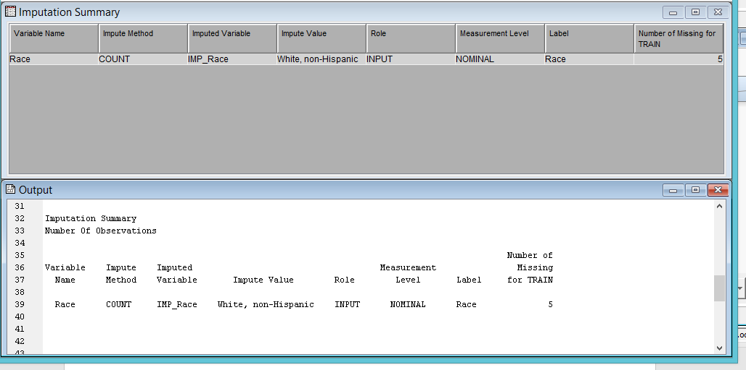
Model
The modelling stage is the last one in the SEMMA data analytics process of SAS Enterprise Miner. The process in this case involved discovery of the prototype and test analytical models. A regression model was used to model the data and the outcome used to model the best predictor of success or participation in immunization programs. The complete diagram of the process including the regression node was as follows;
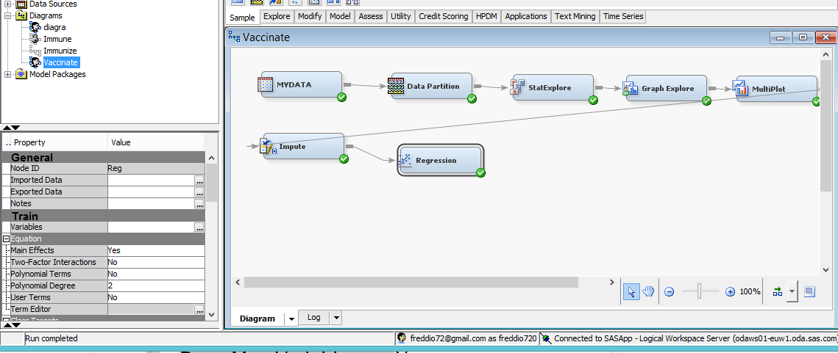

The result of the regression was as follows;
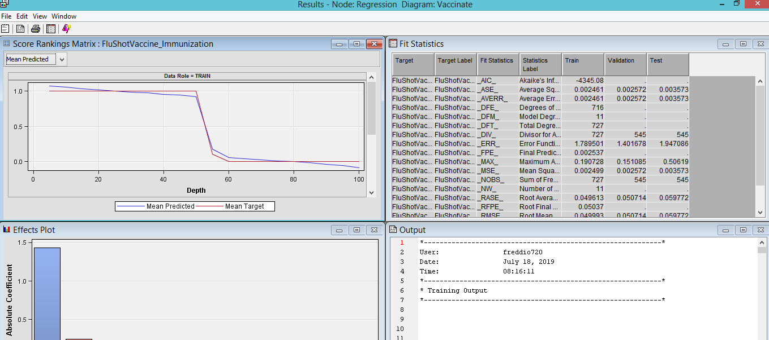
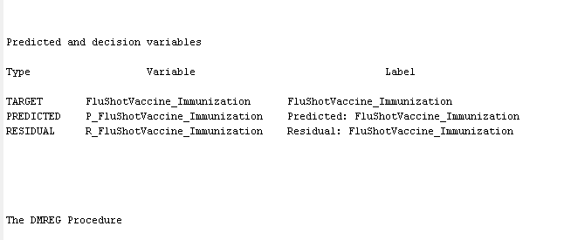
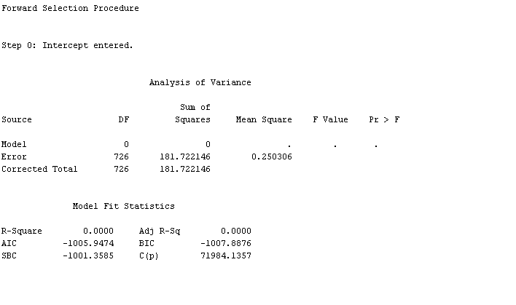
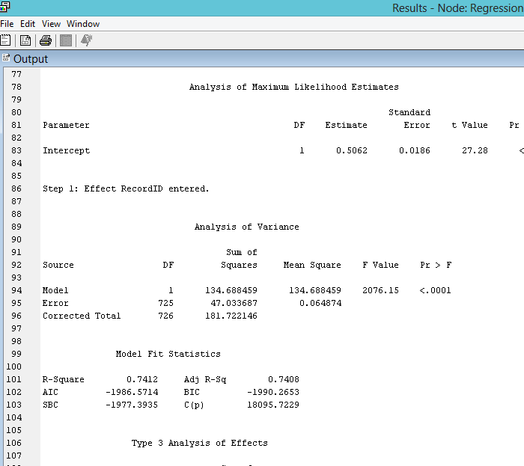
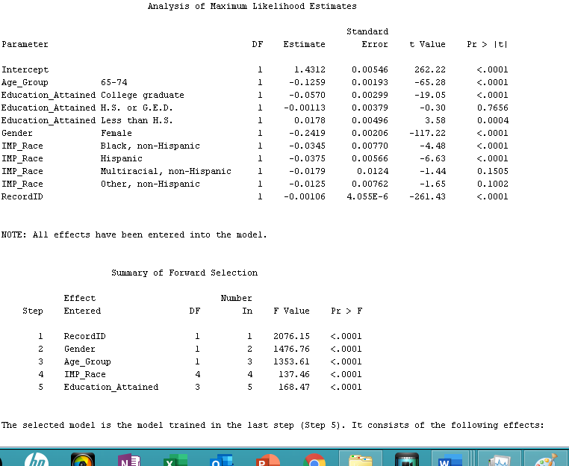

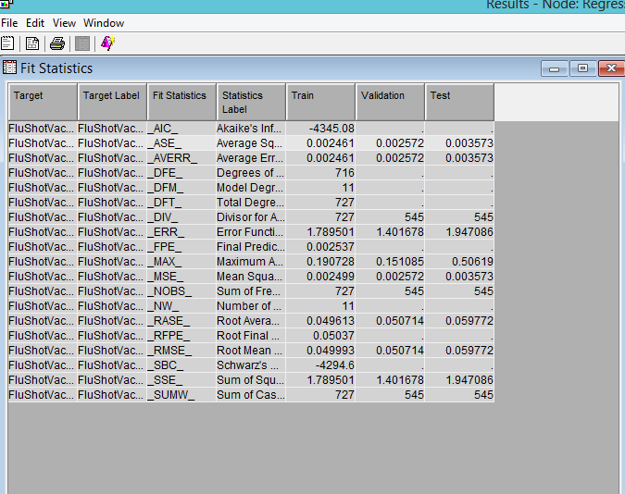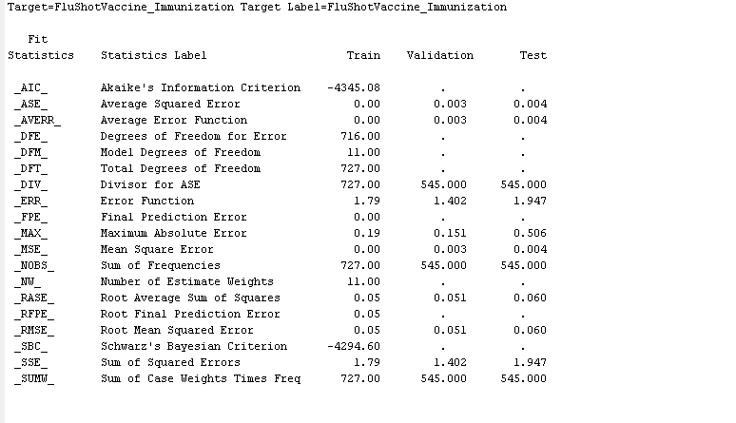
Overall summary sampling recommendations, findings, insights
The analysis revealed that gender, age group, race and education are significant predictors of immunization
  - Summary healthcare/clinical recommendations
From the analysis, its clear that gender, age group, race and education are significant predictors of immunization. Healthcare organizations must therefore sensitive people from different age groups, genders and education on the benefits of immunization.
Model advantages / disadvantages
The main advantages of using a model based on forward selection is that it attains parsimony easily by using smaller models quicker to model a scenario. Additionally, it’s less perceptible to multicollinearity. Finally, it shows the most important predictors
The disadvantages of such a model include;
- The need to include more models
- The possibility of predictors becoming redundant if they are entered early

References
Madhu, G., & Nagachandrika, G. (2016). A New Paradigm for Development of Data Imputation Approach for Missing Value Estimation. International Journal of Electrical and Computer Engineering, 6(6), 3222.
Ventola, C. L. (2016). Immunization in the United States: recommendations, barriers, and measures to improve compliance: part 1: childhood vaccinations. Pharmacy and Therapeutics, 41(7), 426.

